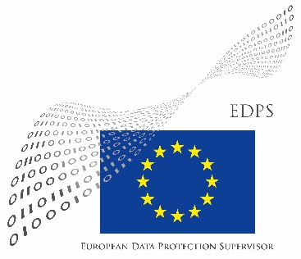
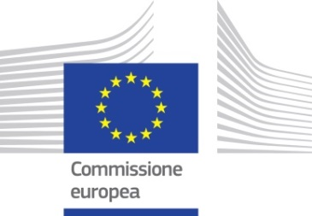

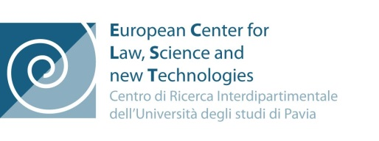
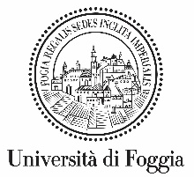

PRIVACY

Courts facing Courts

Access and use of data
within and outside European Union

1st session: OCTOBER 13, 2016

2nd session: OCTOBER 14, 2016

9,30 – 13,15 - 14,30 – 18,00

Aula Magna “Emilio Alessandrini - Guido Galli” -
Palace of Justice of Milan - Corso di Porta Vittoria Milan
1st session: Thursday, OCTOBER 13, 2016
9,00 -9,30 Registration of participants

9,30 welcome and opening remarks

Milan Bar Association - President of the Council - Avv. Remo Danovi
University of Milan – Dean of the Law Faculty - Prof. Nerina Boschiero
EUROPEAN COMMISSION – Representation in Italy – Dott. Francesco Laera – Press and Media Officer

9,50 PANEL 1 Industry, work and new technologies:
privacy in the world 4.0
Chairperson: Dott. Francesco MANNINO, Judge - Pres. III Section “Company Court” in Rome

Dott. Amedeo SANTOSUOSSO - Pres. I Section Milan Court of Appeal - Dott.ssa Marta TOMASI- University of Pavia
EUROPE – The time and space of privacy in the age of new tecnologies

Prof. Ugo PAGALLO – University of Turin
EUROPE & USA – The privacy of groups in the age of Big Data

Prof. Avv. Gianpaolo Maria RUOTOLO – University of Foggia - King’s College London
EUROPE & USA – Across the great divide: personal data and international law
****Coffee Break****
11,30 resumption of works
Chairperson: Avv. Daniele VECCHI – Europe Group of the Observatory on Civil Justice of Milan

Dott. Giovanni BUTTARELLI – European Data Protection Supervisor
EUROPE – From Directive 95/46 to the new Regulation EU 2016/679

Avv. Monia BACCARELLI – Europe Group of the Observatory of Milan - Florian TRAUB Rechtsanwalt - UK and Germany
EUROPE & USA – Discovery and privacy in IP proceedings

Avv. Claudia DEL RE - Florence
EUROPE – The rules of privacy in Europe and Italy: a new protection for confidentiality after Reg.EU 2016/679

13,15 – 14,30 Lunch
14,30 welcome and opening remarks

Italian Judicial Superior School - Vice-president - Avv. Andrea Del Re
Observatory on Civil Justice of Milan - Coordinator - Dott.ssa Elena Riva Crugnola – Judge - President -B) Section- “Company Court” in Milan
Milan Bar Association – EU Law Committee - Avv. Francesca Cunteri
UIA - Union Internationale des Avocats - Président du Comité National pour l’Italie - Avv. Alessandro Colavolpe

14,45 PANEL 2 Litigation and privacy
in the age of society 4.0
Chairperson: Avv. Silvia TOFFOLETTO – Coordinator of the Europe Group of the Observatory on Civil Justice of Milan

Dott. Francesco CONTINI - CNR National Research Council - IRSIG
EUROPE – Privacy and information systems in the administration of justice. A glance at Europe

Dott. Vincenzo DI CERBO - President of Labour Sec. at Supreme Court and Director of CED of the Supreme Court
Between the right to privacy and the need for trasparency in judicial activities. The case-law databases of the Italian Supreme Court

Dott. Pasquale LICCARDO - Italian Ministry of Justice -Board of Automated Information Systems - General Director
ITALY – The proceedings in the age of society 4.0

Dott. Enrico CONSOLANDI – Judge at the Court of Milan
ITALY & EUROPE – A “predictable” litigation

Prof. Avv. Paolo MONDINI – Catholic University of the Sacred Heart
EUROPE & ITALY – Enterprises and predictability of decisions

Avv. Cristina BELLINI – Member of the Milan Bar Association Council
ITALY & EUROPE – Litigation, privacy and ethics in society 4.0
17,30 – 18,00 Q&A
2nd session: Friday, OCTOBER 14, 2016
9,00 -9,30 Registrazione partecipanti
9,30 welcome and opening remarks: President of the Court of Milan- Pres. Dott. Roberto BICHI
Milan Bar Association – EU Law Committee - Avv. Manlio Marino

9,50 PANEL1 Privacy and EU citizens in the society 4.0
Chairperson: Dott. Francesca FIECCONI, Judge Milan Court Appeal, Coordinator of the Europe Group of the Observatory on Civil Justice of Milan

Avv. Bruna GABARDI VANOLI
Public administration and citizens: privacy and right of access in the age of society 4.0

Avv. Massimiliano PUGLIA - European Court of Justice -
Référendaire - Chambers of Judge Tizzano
EUROPE – Personal data protection in the recent decisions of European Court of Justice

Avv. Agostino MIGONE DE AMICIS – President Ethics Commitee Humanitas
Clinical trials and privacy in the perspective of Reg. EU 2014/536 and 2016/679

****Coffee Break****
11,30 resumpion of works
PANEL 2 Between present and future: robot-man or „man-robot“ ?
Chairperson: Dott. Angelo MAMBRIANI, Judge - B) Section “Company Court” in Milan

Avv. Maria Laura GUARDAMAGNA - Milan - Luxembourg -
EUROPE - Doping and restrictions on the right to privacy for athletes

Avv. Roberto VALENTI – Chairman at Life Science Working Group Amcham -
USA - EUROPE – Life science: what future ?

Dott. Andrea AGNELLO - Program Director of the Watson Health Center of Excellence - IBM Italy -
Cognitive systems and Health - IBM Watson Health
13,15 – 14,15 Lunch
14,30 Welcome and opening remarks:
Milan Bar Association – Member of the Council Avv.Laura Cossar

14,40 PANEL 3 Privacy and employment: challenges between
technological innovation and need for protection

Chairperson: Dott. Piero MARTELLO - Judge - President - Labour Section at the Court of Milan

Dott. Roberto LATTANZI
Data Protection Authority – Department of communications and telematic networks
Monitoring tools and working tools: what privacy for employees?

Dott. Guido VIDIRI – Past President of Labour Section at Italian Supreme Court
Remote control of workers under the Jobs Act between present and future

Avv. Roberto COSIO - Pres. Comm. Labour UAE - Catania
EUROPE & ITALY – Control over religion identity: influence on the employment relationship

Avv. Gigliola PIROTTA – Europe Group of the Observatory of Milan
EUROPE & USA – „Whistleblowing“ between protection of privacy and public interest

Dott. Stefano BOTTINO - ABI Associazione Bancaria Italiana
New technologies and organization of work, between protection and production needs

Dott. Marco Giorgio BERSELLI - InTLL - International Labour Law
EUROPE – Privacy & smart working
17,30 – 18,00 Q&A
CLOSING REMARKS of the session
Free admission, the partecipation at the event for the lawyers grants no. 8 legal education credits of wich no.1 in ethics.
REGISTRATION for lawyers: www.ordineavvocatimilano.it (Formasfera) - Info: avv.toffoletto@gmail.com

More info on:
www.milanosservatorio.it
www.giurisprudenzadelleimprese.it
www.ec.europa.eu/italy

